TEXT FILE:

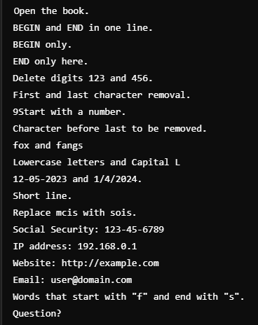

Write a sed command to

1. print lines numbers of lines beginning with “O”

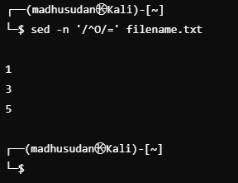

1. delete digits in the given input file.

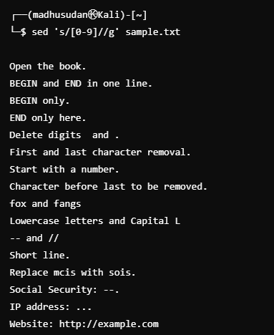

1. delete lines that contain both BEGIN and END

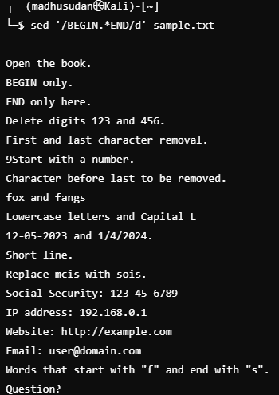

1. delete lines that contain BEGIN but not END

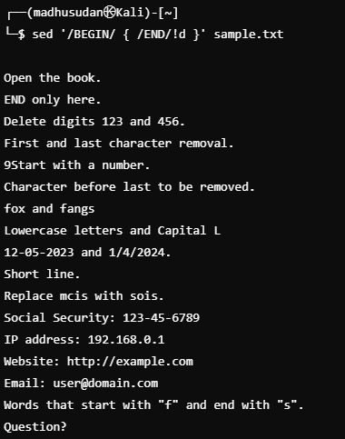

1. deletes the first character in each line in a file

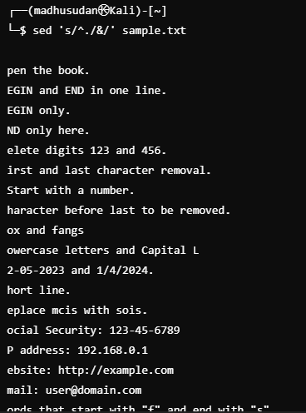

1. deletes the last character in each line in a file

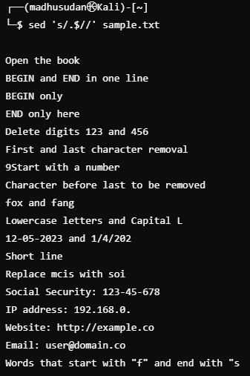

1. deletes the first character, (if it numeric ) in each line in a file.

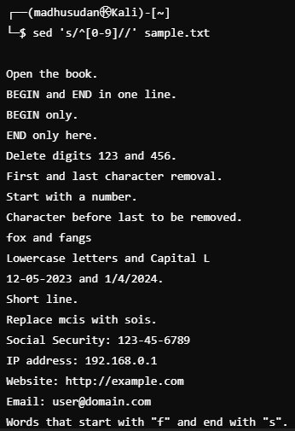

1. deletes the character before the last character in each line in a file.

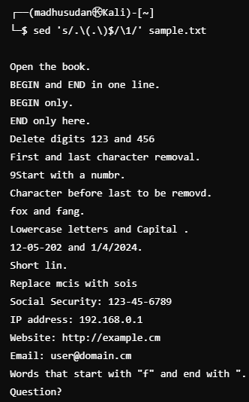

1. that swaps the first and second words in each line in a file.

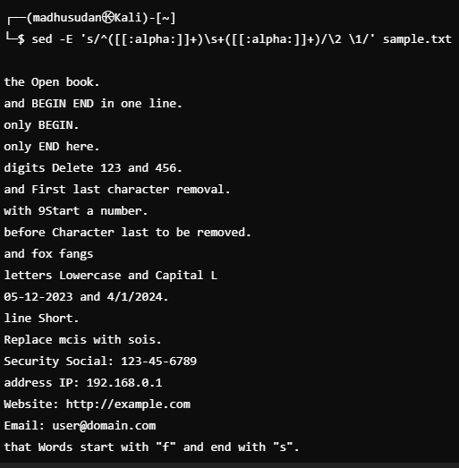

1. replace the word “mcis” with “sois” in the first five lines in a file

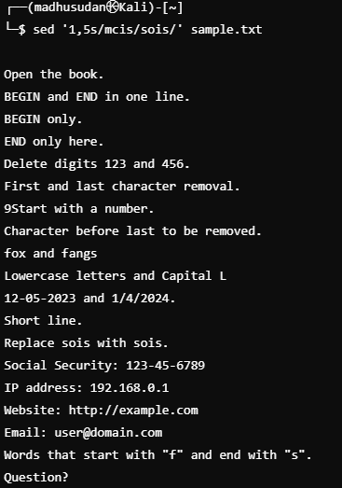

1. add “SOIS” prefix to all the lines

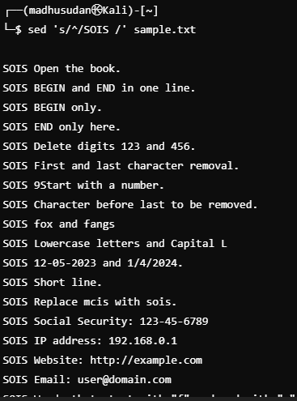

1. add “.” at the end of each line in the file.

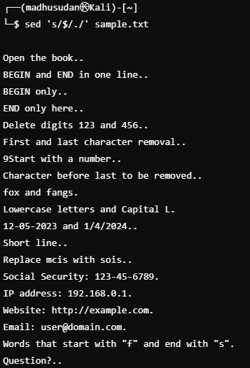

1. Pick the line with Social security number in the format of 999-99-9999

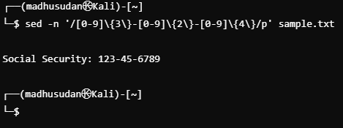

1. Pick the Valid IP address of the computer (4 numbers separated by ‘.’). (e.g. 192.168.0.1)

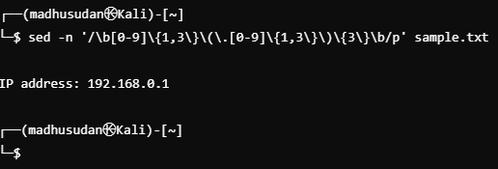

1. Pick the Valid URL beginning with “http://”. (e.g. <http://manipal.edu>)

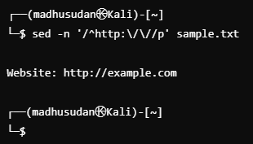

1. Pick the Valid email address, assuming ‘a-z’,’0-9’,’-‘,’.’ are the valid characters for user ID, and domain name has to end with either “.com” or “.net”

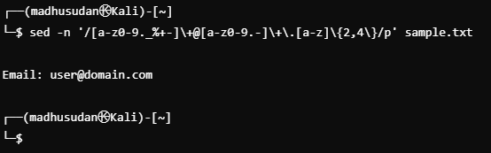

1. Print all lines containing words that start with "f" and end with "s".

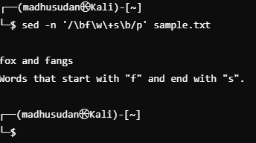

1. Print lines containing a capital "L", but not as the first character on the line.

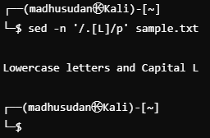

1. matches dates in the American MM-DD-YYYY format where months and days can be 1 or 2 digits, years must be 4 digits starting with a 1 or a 2, and the delimiter is either "-" or "/" but not both.

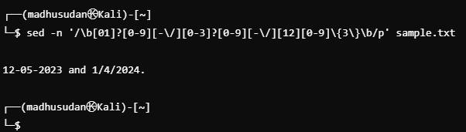

1. print all the lines of a file that are less than 10 characters in length.

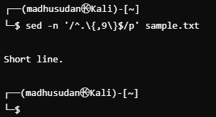

1. replace all occurrences in a file of "the" with "a" and "The" with "A".

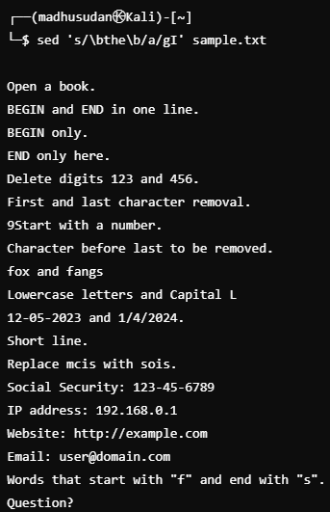

1. substitute the word "button" for "tree", only if tree occurs at the end of a line.

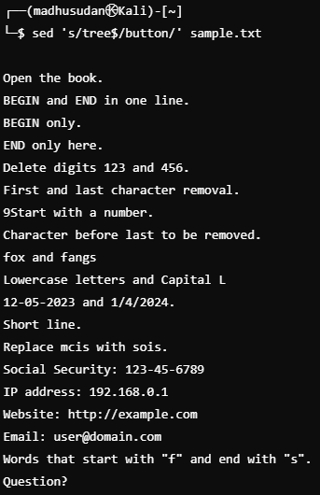

1. substitute the word foible for the word tree but not the word trees.

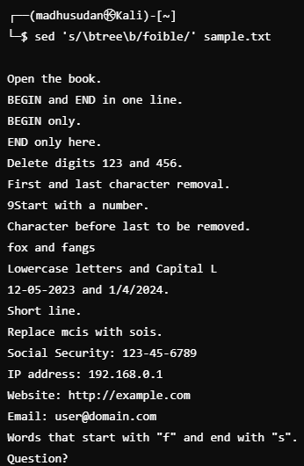

1. change a text so that every period at the end of a sentence is changed to an exclamation point (!) and every question mark is replaced with an ellipsis (...)

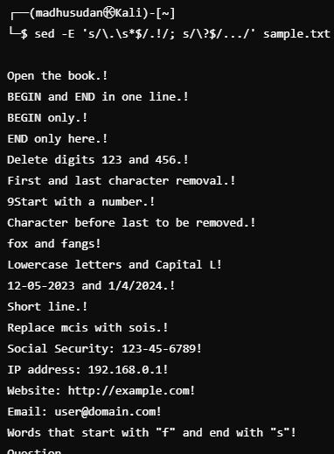

1. Change every occurrence of the word 'me' with 'you' but only at the end of a line.

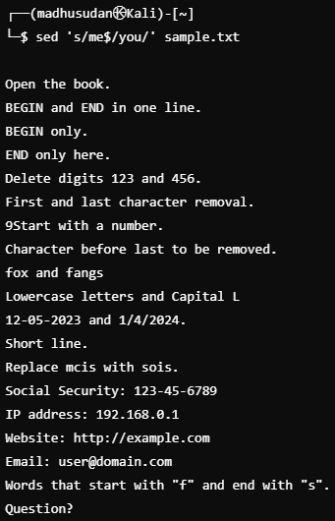

1. change a document so that every occurrence of a three-letter abbreviation for a month is replaced by the appropriate number, i.e., Jan is replace by 1, Feb by 2 etc.

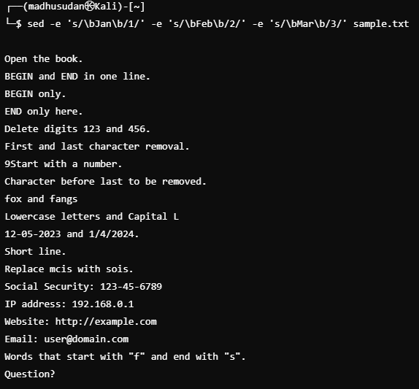

1. match lines containing (i) Jefferies jeffery jeffeys (ii) hitchen hitchin hitching (iii) Heard herd Hird (iv) dix dicks dickson dixon (v) Mcgee mcghee magee.

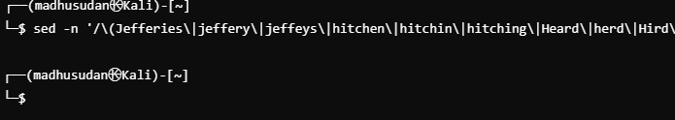

28. replace all multiple spaces in a string by only one space.

29. A line comment in C is introduced by the sequence //. Alternatively the comment can be enclosed by /\* and \*/. Write a sed command which transforms the // comments to the enclosed ones.

